- Answer in remainder form: 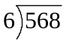
- 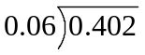
- 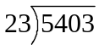
- 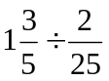
- 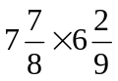
- 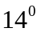

- Answer in remainder form: 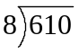
- 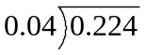
- 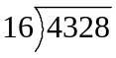
- 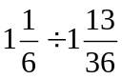
- 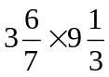
- 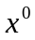

- Answer in remainder form: 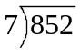
- 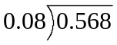
- 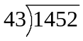
- 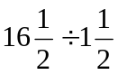
- 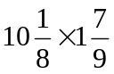
- 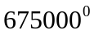
- Answer in remainder form: 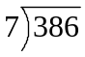
- 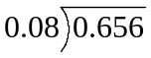
- 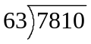
- 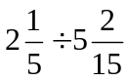
- 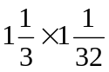
- 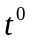

- Answer in remainder form: 
 